COURSE INFORMATION SHEET
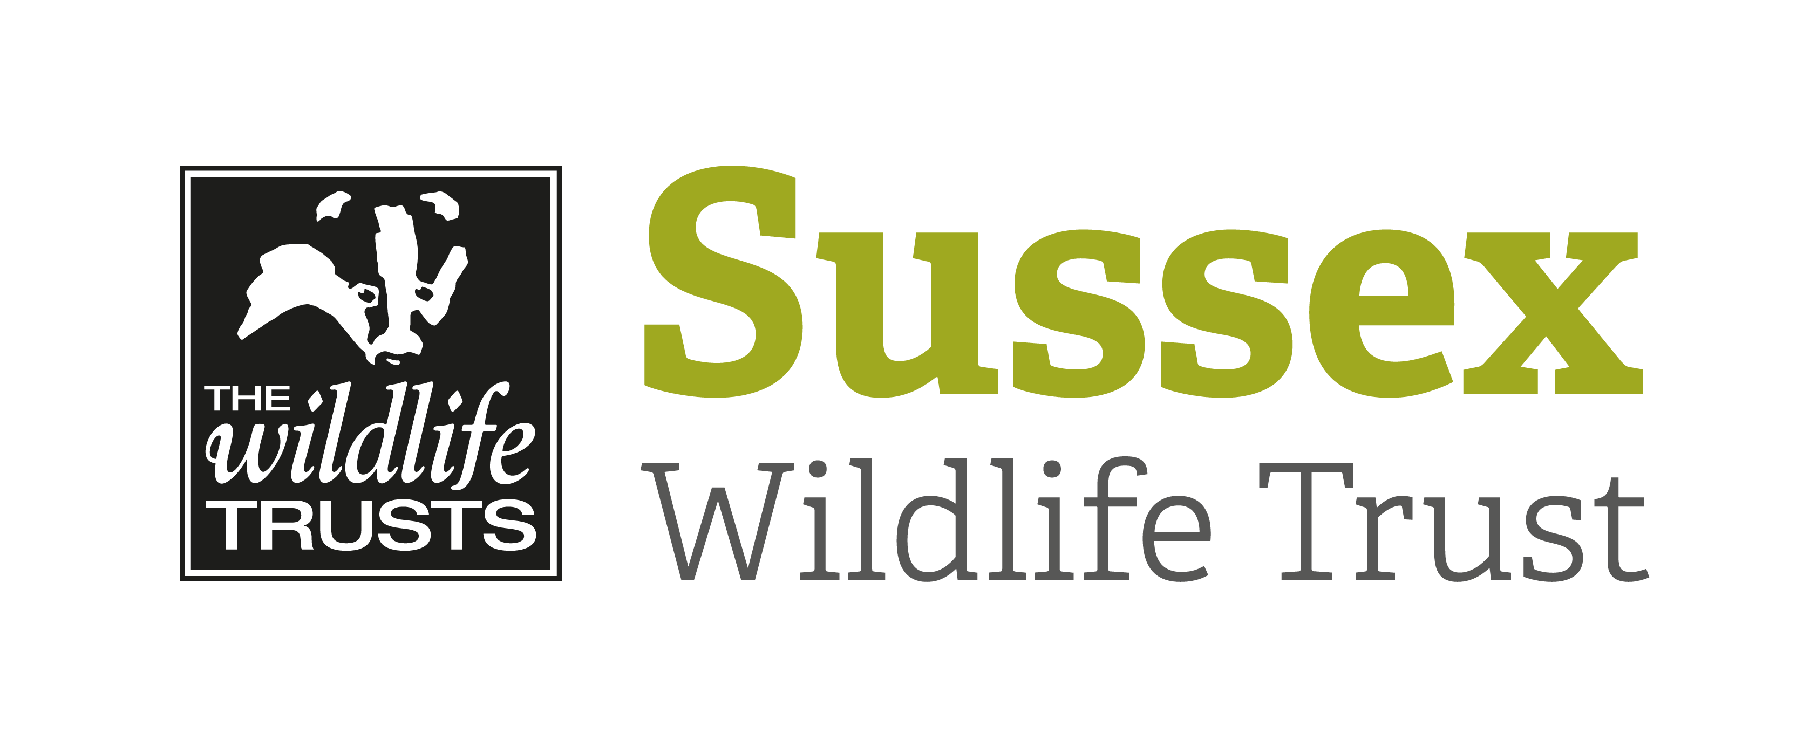

Course Title: An Introduction to True Bugs |  |  | Day/Date/Year:  Friday 7 August 2020
Start Time: 10am |  | Finish Time: 4pm
Course Tutor: | Graeme Lyons
Course description and subjects covered | Around 1,800 species of insects in Britain are classed as ‘true bugs’ (Hemiptera). They include the familiar shieldbugs and leatherbugs as well as many other related families. These insects are often colourful and well patterned but although ubiquitous the true bugs are often overlooked. 467 different species have been recorded in Sussex.  This new one day course, led by Sussex Wildlife Trust’s Senior Ecologist Graeme Lyons will give you a background introduction to the Hemiptera and then we will be out searching for and learning how to identify bugs on the nature reserve. The course will mainly focus on the Heteroptera ( which includes the shieldbugs, leatherbugs, stiltbugs and plant bugs) and with 111 species on the Woods Mill Heteroptera list there will be plenty to keep us busy!
Meeting point/Venue address & nearest post code | The Classroom, Woods Mill, Henfield, West Sussex, BN5 9SD
Other sites to be visited: | Woods Mill nature reserve.
What to bring: | Please bring hand lenses, sweep net and pots if you have them although some will be available to share on the day.  Lunch / drink as required.  We will be outdoors for most of the day so please wear appropriate clothing for the weather.  Please may we ask that you take all packed lunch waste home with you.
Other Information: | Coffee & tea available in the morning.  Public toilets are available in the car park.
Public Transport: | Compass Bus Service 100 passes Woods Mill. See online timetables.
Accessibility: | There is disabled access to classroom and reserve.

