COURSE INFORMATION SHEET
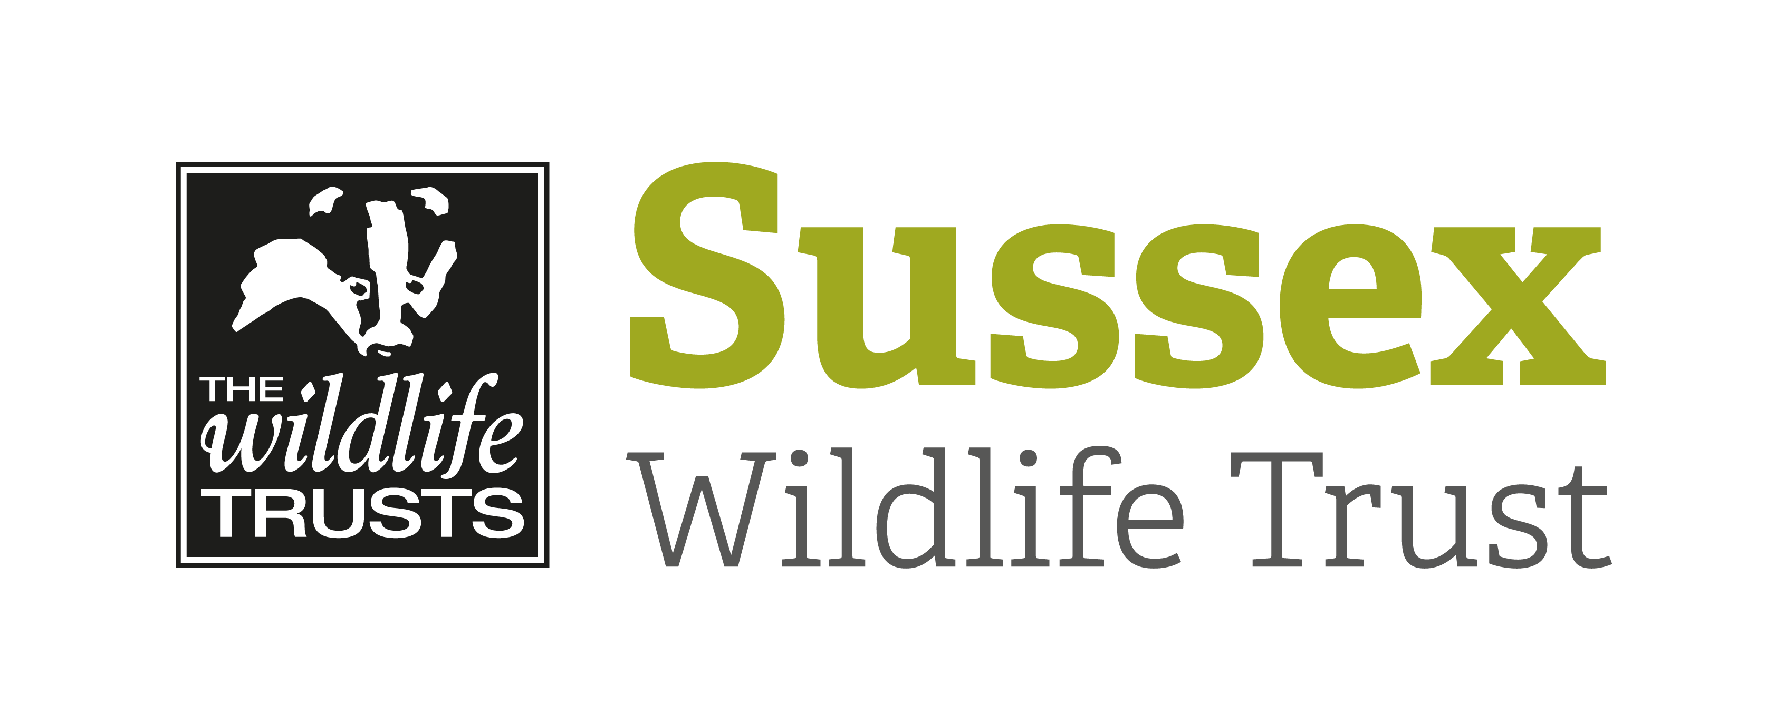

Course Title: An Introduction to Fungi |  |  | Day/Date/Year:  Wednesday 2 October 2019
Start Time: 9.30am |  | Finish Time: 3-4pm
Course Tutor: | Martin Allison
Course description and subjects covered | In the Autumn the woodlands of Sussex contain an incredible diversity of amazing fungi in an incredible array of sizes, shapes and colours. But with thousands of species in Sussex alone where do you start when it comes to accurately identifying them?  Fungi expert Martin Allison will give you the perfect opportunity to learn all about fungi on this one-day course aimed at beginners.  After meeting for an introduction (and tea /coffee) in the morning we will head out on a fungi foray at Brede High Woods looking at the diverse range of woodland fungi that can be found here. Samples will be taken back for the indoor section of the course held at a local village hall. After lunch, Martin will give a short presentation. Following that, with the help of microscopes and Martin’s guidance, we will familiarise ourselves with the structures which help us to accurately identify fungi.
Meeting point / Venue address: | The Jenkins Room, Northiam Village Hall, Frewen Close, Northiam, Rye, East Sussex, TN31 6AF  We will then car share (10 mins) to a local site to look for fungi.
Other sites to be visited: | Brede High Woods.
What to bring: | Please wear appropriate outdoor clothing and footwear for walking on possibly muddy paths  Notebooks/pencils/field guides  Packed lunch
Other Information: | Tea/coffee and biscuits will be provided.  Free parking  Toilets available at village hall.
Public Transport: | The Hastings-Tenterden bus service serves Northiam along with a number of local buses.
Accessibility: | Gentle walk, but paths may be muddy.

