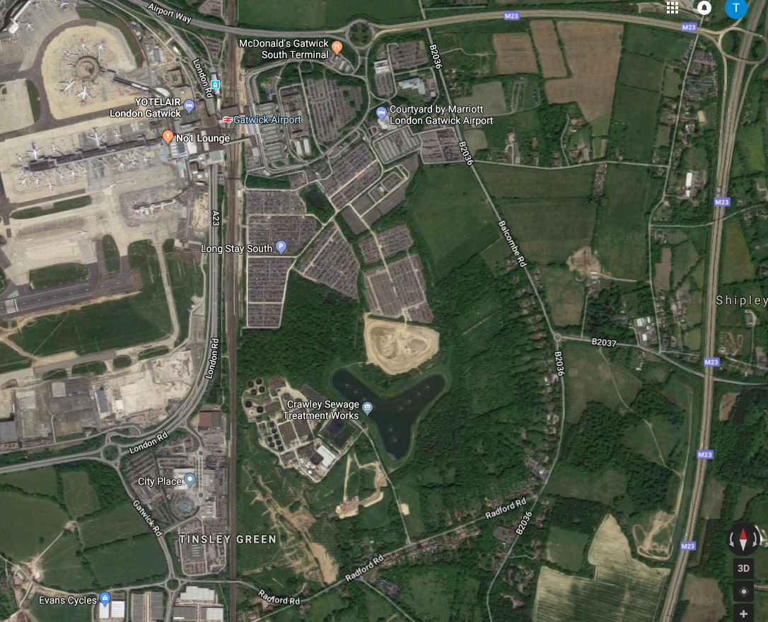
Gatwick Woodlands
Meeting point
/Parking
Upper Pickets Wood
Horleyland Wood
Lower Pickets Wood
Goat Meadow

- Bus Stops

Upper and Lower Pickets are small Hazel and Hazel/Hornbeam Coppiced woodland owned by Gatwick Airport Ltd. They form part of a mosaic of woodlands and grasslands which include Horleyland Wood, an ancient semi-natural oak woodland designated as a Local Wildlife Site and the grassland sites of Goat meadow and the Gatwick Stream.
There are basic facilities onsite including a portable toilet, shelter and hand wash. The woods are situated just west of the A23 and East of Gatwick Airport so are close to amenities and easily accessible by car. There is room to park vehicles onsite just a short walk from where activities will be taking place.

Public Transport: Nearest bus stops Radford Rd opp the greyhound Pub or Forge Wood bus stop, Steers lane. Both approx. 15mins to the meeting point.

It is possible to access the site via a public footpath from Gatwick South Terminal Train station. This is about a 20 minute walk but please plan your route carefully before setting out.

We apologise that this location has extremely limited wheelchair access. There is a portable toilet and free parking at the meeting point.
The meeting place is The Gatwick Biodiversity container, Rolls Field parking area, off the Thames Water access track, Radford Road, Tinsley green, Crawley, RH10 3NS

The post code gets you nearby with a sat-nav but will not pick up the exact location. This link takes you to the meeting place: https://goo.gl/maps/pWJUuEQdyhPopzie7

Directions from Horley:
• Head south out of town on the B2036 (Balcombe rd)
• Continue on the B2036 passing underneath the A23
• At the roundabout take the 2nd exit to continue on the B2036.
• Pass the pittstop garage and turn right onto Radford Rd following signs for Gatwick Airport and Manor Royal
• Turn Right when you see the sign for Thames water, Crawley Sewage treatment works
• go through two large blue metal gates,
• make your way down the track and park in an area of hardstanding on the left, in front of a shipping container with a Gatwick Biodiversity sign on it.

Directions from Crawley:
Leave Crawley via three bridges, head up Worth Park Ave
Take the first exit at the roundabout onto the B2036 Balcombe rd
Continue along Balcombe rd past the crematorium
turn left onto Steers lane (signposted for forge wood new homes as pictured below)
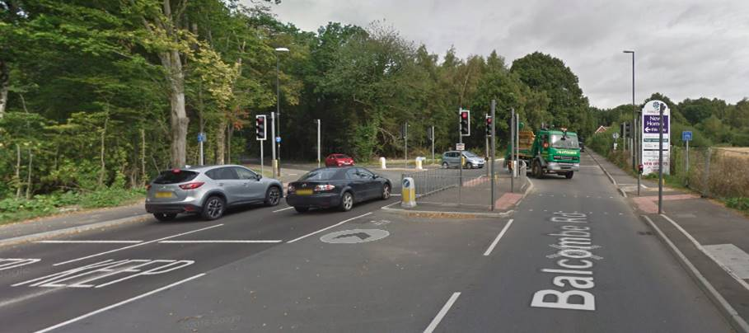

Turn a right at the end of steers land onto Radford rd
Turn left at the Thames water sign
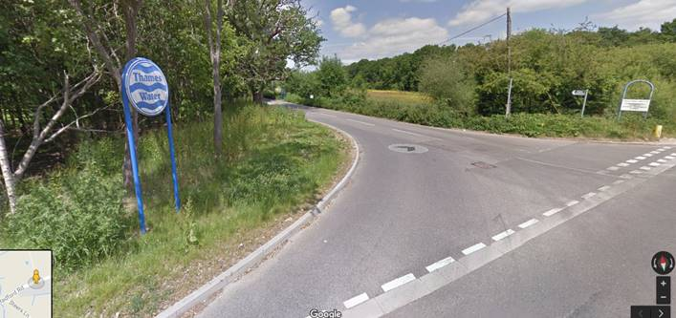
Continue through the large blue gates and park in an area of hardstanding on the left, in front of a shipping container with a Gatwick Biodiversity sign on it.

Directions from Horsham:
- Head through Crawley on the A23 London rd
- Turn right (3rd exit at) the Gatwick rd roundabout onto Gatwick rd
- Continue on Gatwick Rd, at the roundabout take the first exit onto Radford rd
- Continue along Radford rd, pass the greyhound pub and straight through the traffic lights.
- Turn left when you see the sign for Thames water, Crawley Sewage treatment works
- Go through two large blue metal gates, park in an area of hardstanding on the left, in front of a shipping container with a Gatwick Biodiversity sign on it.

