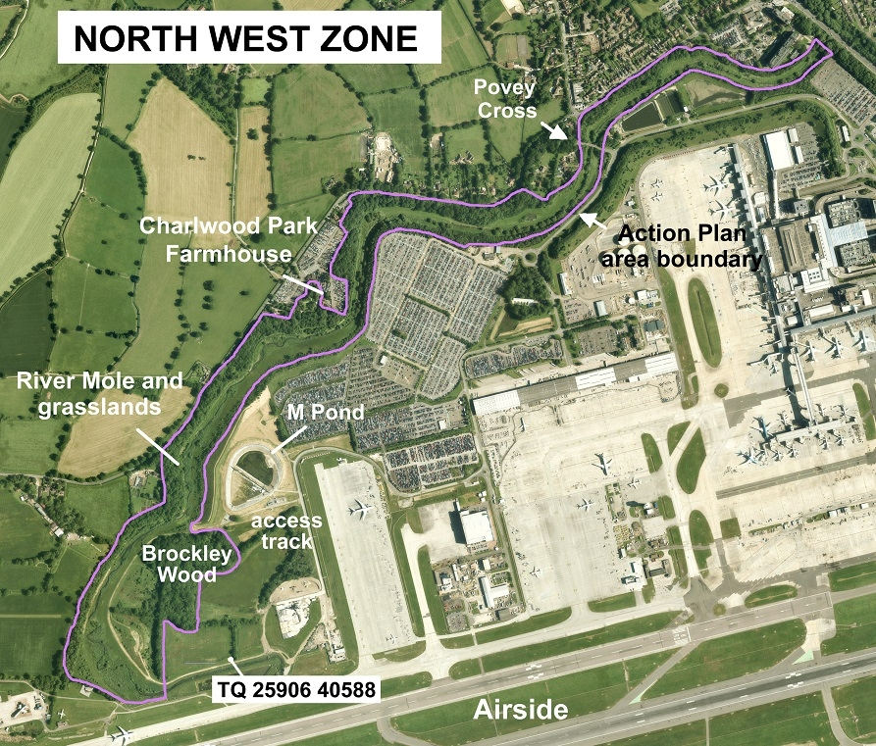
River Mole, Gatwick

The River Mole channel is located immediately north of the western end of the airfield, the river flows north-east towards Horley. The floodplain grasslands are rich in wildflowers including agrimony, water mint, purple loosestrife and meadowsweet. There are 2 meeting points along the river for Gatwick Greenspace events; The Bear and Bunny Nursery (formerly Charlwood Park Farmhouse) and Povey Cross Road, both of which are off the Charlwood/Horley Rd.

It is possible to access the site via a public footpath from Gatwick North Terminal. This is about a 20 minute walk and a separate map can be provided on request.

Neither of these locations have toilet facilities, participants in our events would be advised to use the facilities at Hookwood Tesco’s in Horley before attending.

Public transport: The nearest bust stops for both locations are at the Povey cross bridge.
Povey cross Rd West is serviced by the Fastway 100 between Maidenbower and Redhill.
Povey cross bus stop is service by Bus 22 which runs between Dorking, Charlwood and Gatwick Airport.

We apologise that this location has extremely limited wheelchair access.

The nearest addresses for sat nav use are:

1 Povey Cross Road  Horley  RH6 0AG | Bear and Bunny Nursery  Crangal Cottage  Horley Road  Charlwood  Horley  RH6 0BJ

Directions from Horley:
Povey cross rd
- Head South-west out of Horley Town Centre on the A23 (Brighton Rd)
- At The Longbridge Roundabout take the 1st exit onto Povey Cross rd,
- Turn left immediately before the chicane (Choices vehicle rentals will be on your right)
- Turn right onto Povey cross rd (signposted as private rd) and Park along the curbside on your right.

Bear and Bunny Nursery
- For the bear and bunny follow direction 1 and 2 above, then continue through the chicane on Povey cross rd/Charlwood rd
- Pass the Gatwick Holiday Parking on your left and The bear and bunny will be the next turning on the left.
- Continue all the way to the end of the track, pass the cottage on your left and park in the hardstanding.

Directions from Crawley:
- Leave Crawley heading North on the Gatwick rd,
- Pass city place and the beehive, take the third exit onto the A23 (london Rd) at the Gatwick rd roundabout
- Continue on the A23 underneath Gatwick South Terminal and railway station buildings.
- Continue along the A23 until you reach the Longbridge Roundabout, Horley. Take the first exit onto Povey Cross rd.
- Follow direction 3 and 4 from Horley above to reach Povey cross
- To reach the Bear and Bunny see above.

Directions from Horsham;
- Take the A264 (Horsham rd) from Horsham to Crawley
- Follow the Horsham rd thropugh Broadfeild
- At the Cheals Roundabout take the first exit onto the A23 (Crawley Avenue).
- Continue on Crawley Avenue, at the roundabout take the second exit to stay on Crawley Avenue.
- At the roundabout take the second exit onto the London Rd
- Continue straight over the next two roundabouts
- At the Gatwick Road roundabout take the second exit to stay on London Rd (A23)
- Follow Directions 3 through 6 from Crawley (above).

