COURSE INFORMATION SHEET
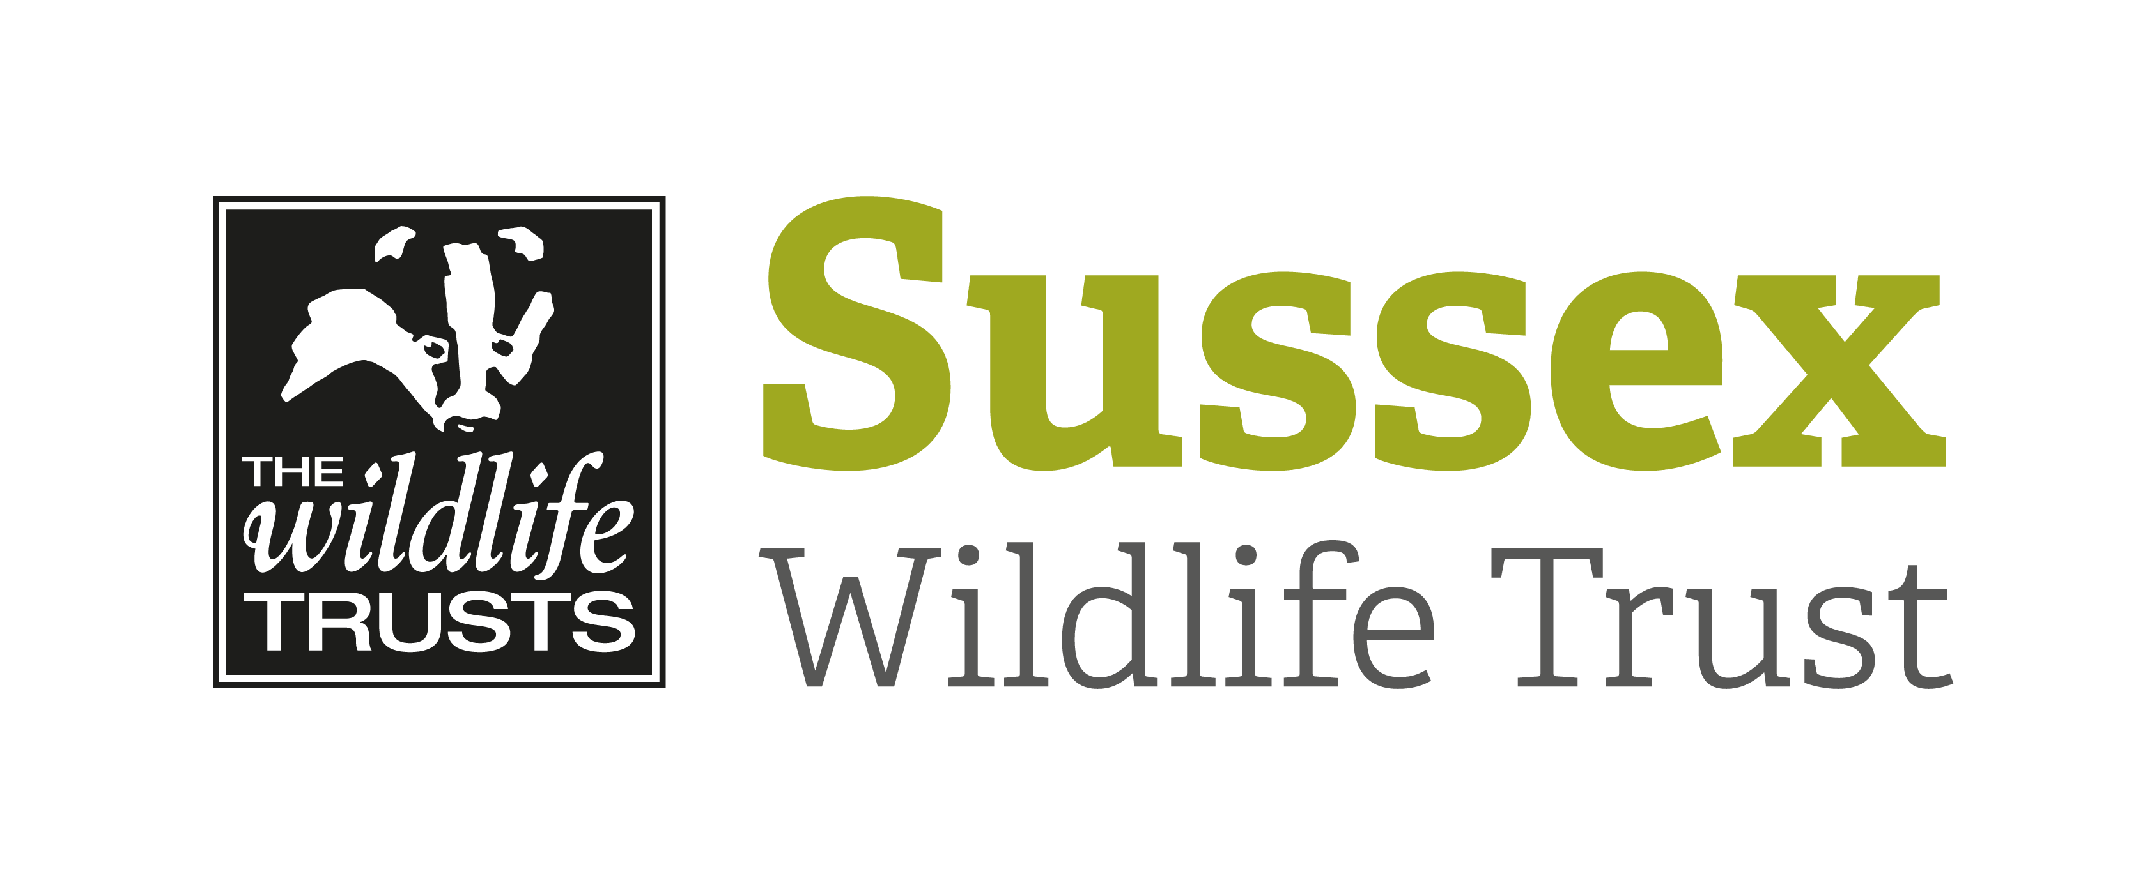

Course Title: Native Reptile Ecology and Surveying |  |  | Day/Date/Year:  Wednesday 6 September 2023
Start Time: 09:00 |  | Finish Time: 13:00
Course Tutor: | Paul Stevens
Course description and subjects covered | Practical onsite transect surveys for all the UK native reptiles.  Learn about their ecology as we explore the West Sussex heathland sites.
Meeting point/Venue address & nearest post code | Meet at Heyshott Common, New Road, near Midhurst.  Grid Reference: SU 91219 19413.  What three words: breached.florists.mailers  Google Map https://goo.gl/maps/841p416Tiy2XQNMbA
Other sites to be visited: | Lavington Common, Duncton Common Road.
What to bring: | Stout footwear necessary.  Camera and binoculars optional.  Drink and snacks if required.
Other Information: | N/A
Public Transport: | Bus route from Chichester station to the town of Midhurst.
Accessibility: | Rough terrain whist on the heathland so sure footing is a must.

