Sussex Wildlife Trust
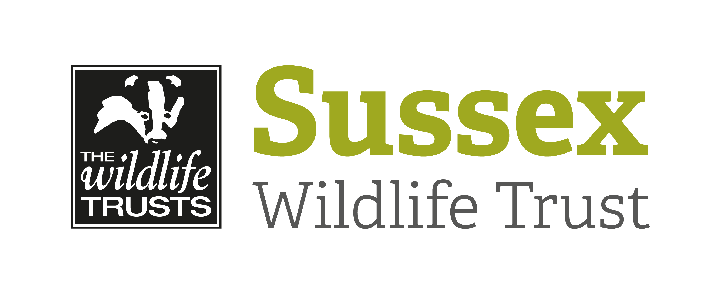

Dive Information Sheet

Event: Seasearch Dives – Rampion Windfarm Area |  |  | Date:  Monday 20/06/2022
Start Time: 09:00 (approx.) |  | Finish Time: 17:00 (approx.)
Organiser: | Ella Garrud; Living Seas Officer
Dive description | Two sites within the Rampion Windfarm area – exact sites to be confirmed.  One dive will be at approx. slack water; the other will be carried out as a drift. Max. depth 30m.
Meeting point / Venue address:  Include nearest Post Code | The boat will be leaving from Pontoon 5, West Jetty, Brighton Marina (BN2 5UP).  Free parking is available in the multi-story car park
What to bring: | Divers need to provide all their own kit (or arrange hire).  This is to include a SMB (or dSMB); a torch is also recommended.  Divers are reminded they will need air for two dives.  Please bring any snacks and refreshments you may wish to have throughout the day. Tea and coffee will be available on the boat.
Other Information: | For information on parking and loading please see:  http://www.channeldiving.com/information/How-To-Find-Us/directions-to-brighton-marina/
Public Transport: | For bringing dive gear it is easiest to arrive by car – please contact the organiser if you might be willing to car share.
Additional Booking Terms and Conditions: | Refunds for non-attendance will be at the discretion of the organiser.  This event will be subject to acceptable weather conditions and sea state; should the organiser need to cancel the dive refunds will be provided.  Divers will be required to provide in advance:  - Diving certification  - Third party diving insurance  - Diving medical certification (or self-declaration)  Divers will also be required to sign on the day to state:  - Tanks in test, gear serviced and checked as working  - Pre-dive buddy check will be carried out  - Valid medical and insurance  - No known medical condition to affect diving safety  - All details provided correct and dive plan understood

