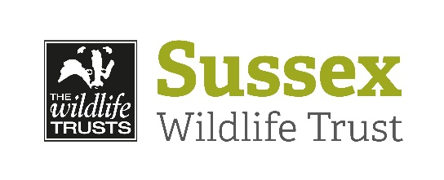
SUSSEX WILDLIFE TRUST

Volunteer Role Description

Role Title:
Survey volunteer – Wilder Horsham District

Location:
Various locations within Horsham District.

Overview/Purpose of the Role:
We are looking for enthusiastic and preferably experienced volunteers to help survey various sites in Horsham for particular taxonomic groups. Principally plants, butterflies (and other invertebrates) and birds. This will give a baseline for sites that are trying to improve for wildlife and help inform management changes to those sites.

Type of tasks you will be involved with:
The three baseline surveys that we are looking for surveyors for are: plant, breeding bird surveys and butterfly transects. Each survey will require between two and four visits during the survey season in Spring and Summer. Let us know which of these interest you.

If you have the experience and/or equipment to perform more specialist surveys for other taxa we would also be interested to hear from you.

Experience/Skills Required:
Essential: Some (good) identification skills for the group you are interested in (training is also available if you are not yet skilled). Enough physical fitness to undertake the survey. Flexibility to adjust survey dates according to weather conditions.

Desirable: We are trying to minimise travel, and carbon emissions, so this position is most suited to someone who lives or works in or near Horsham District. Flexibility in availability would also be useful.

If you are an experienced surveyor/naturalist and are willing to be partnered with someone to pass on your knowledge that would be much appreciated.

Days/Times we would like you to be available:
Varies according to the survey and landowner demand, but generally no more than four days between late March and late September.

Benefits to volunteer & possible training opportunities:
Training in the survey techniques can be given if required
Identification training is available through SWT courses (both online and in person) and through shadowing other volunteers or SWT staff.
Access to hidden corners of the District.
Travel expenses.

Responsible to:
Richard Black and Chloe Harrison

Application Procedure:
Application Form - Registration form

Please fill in the online google form and state which role you are interested in. You do not need a google account to fill in the form - just hit the ‘next’ button on the bottom left. Then submit the form when you have filled it in. If this link does not work for you, or you would prefer a form sent to you in the post, please email swtvolunteering@sussextw.org.uk.
Thank you!

Closing Date:
We are always open to new volunteers!

